|  |
| --- |
| Microservices with Spring Boot 3 and Spring Cloud |
|  |

# WEEK 5:

1.Creating Microservices for account and loan:

Controller:

@RestController

@RequestMapping("/account")

public class AccountController {

@GetMapping("/{id}")

public Account getAccountDetails(@PathVariable String id) {

return new Account(id, "Savings", 10000.50);

}

}

Main:

@SpringBootApplication

public class AccountServiceApplication {

public static void main(String[] args) {

SpringApplication.run(AccountServiceApplication.class, args);

}

}

Account – Output:

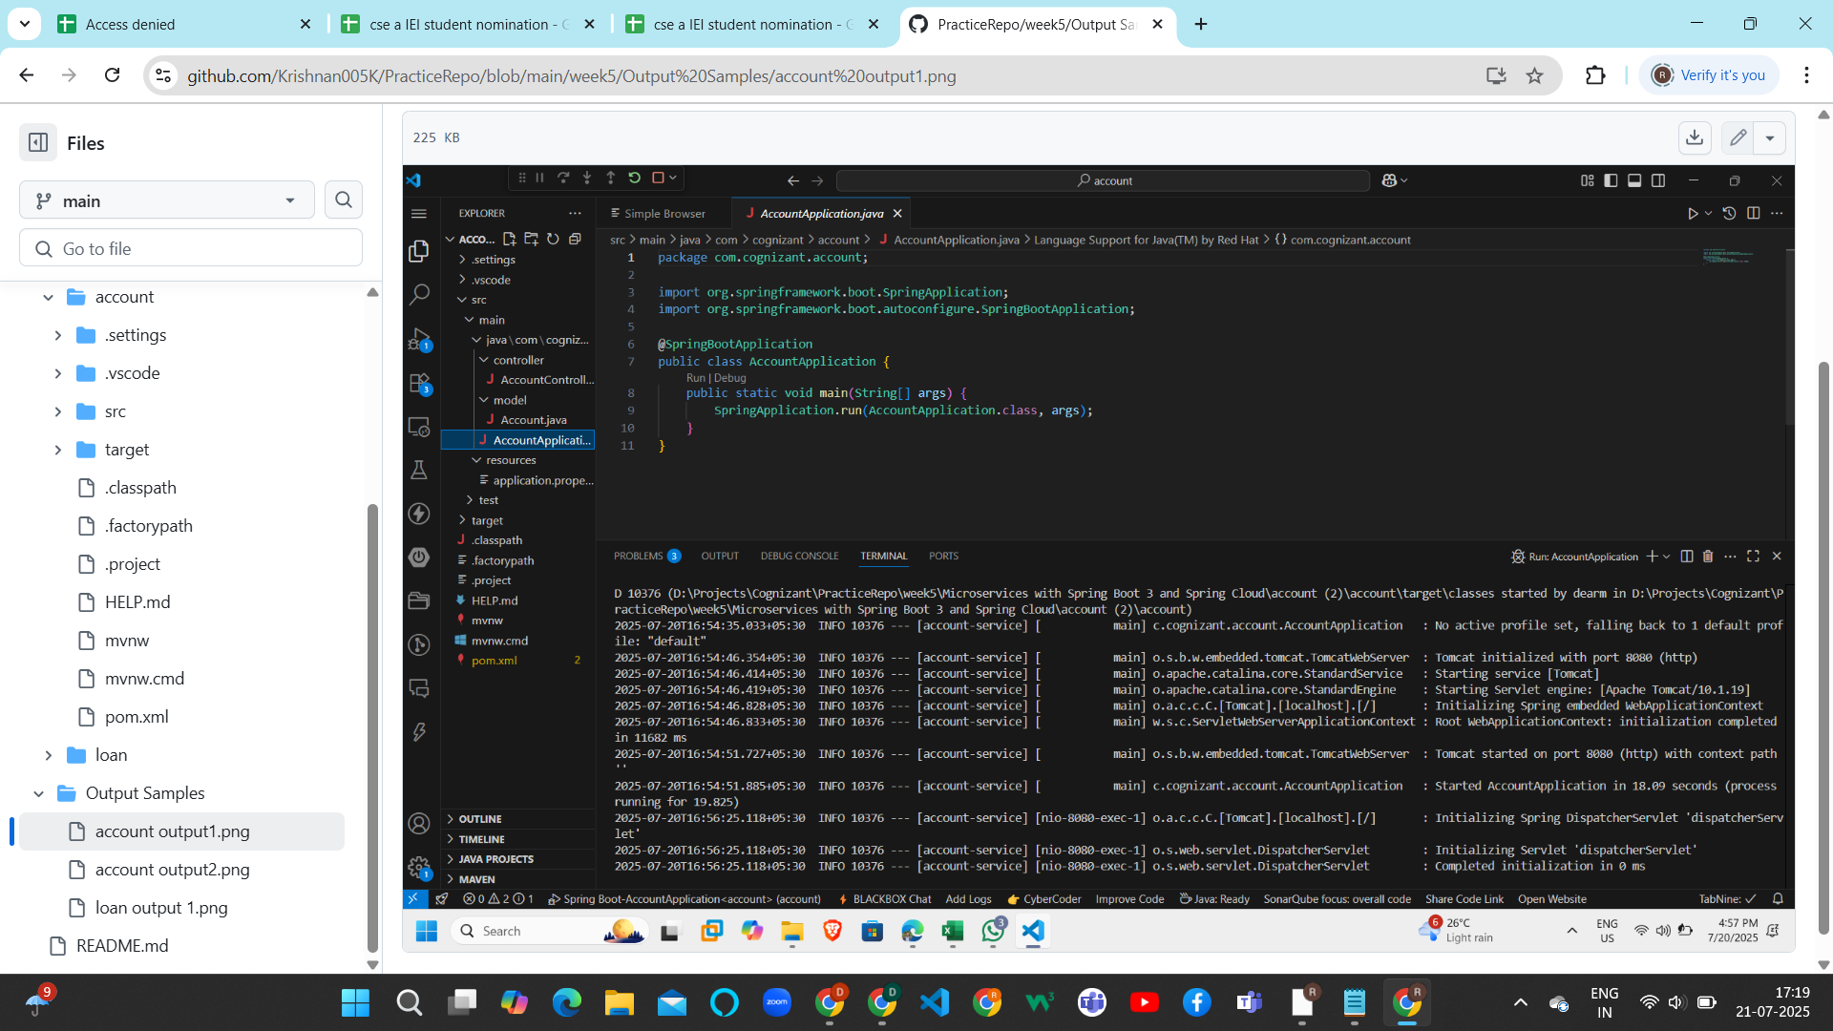

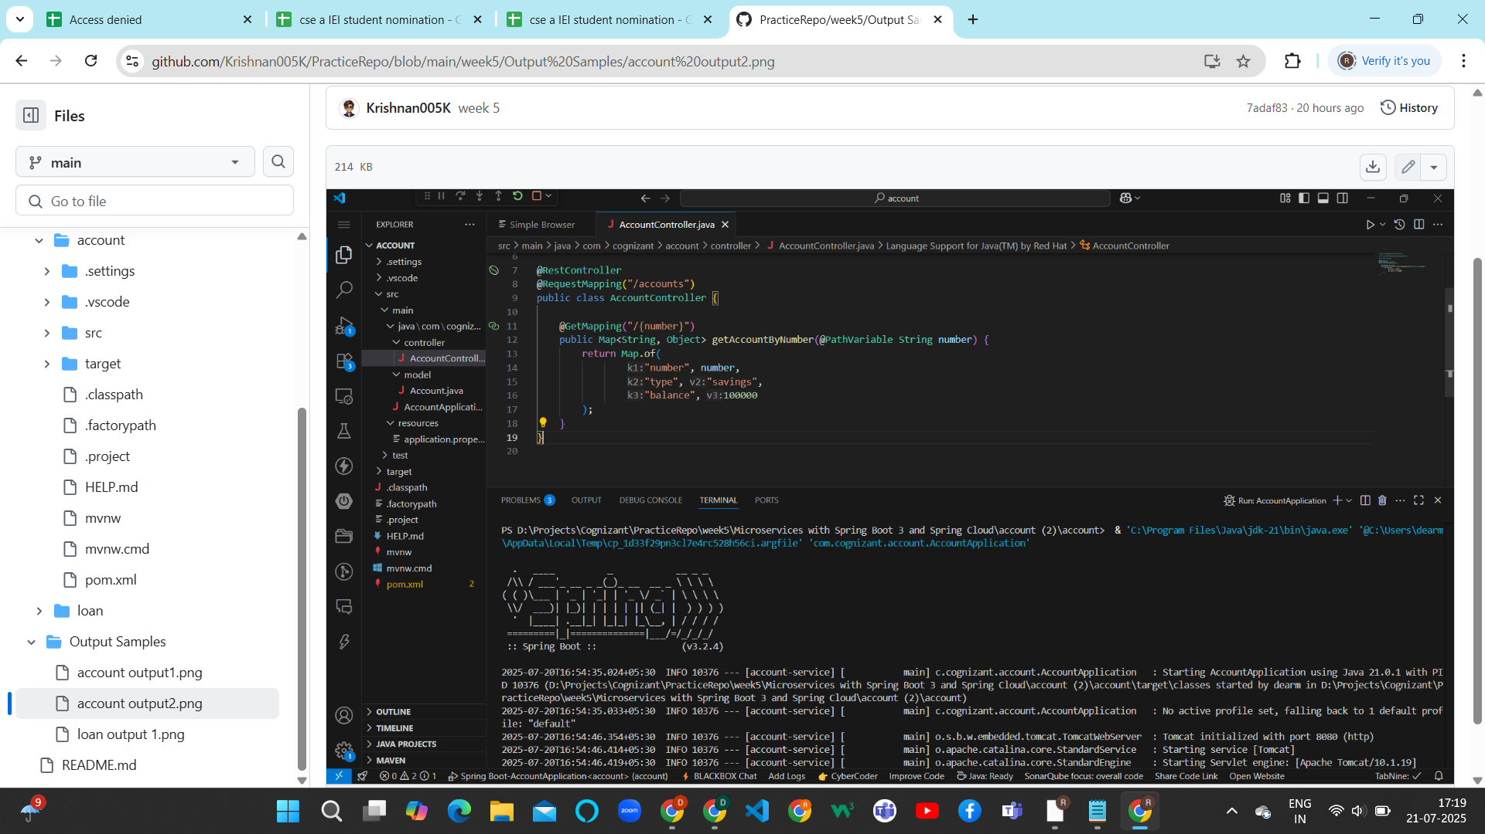

LoanService:

Main:

@SpringBootApplication

public class LoanServiceApplication {

public static void main(String[] args) {

SpringApplication.run(LoanServiceApplication.class, args);

}

}

Controller:

@RestController

@RequestMapping("/loan")

public class LoanController {

@GetMapping("/{id}")

public Loan getLoanDetails(@PathVariable String id) {

return new Loan(id, "Home Loan", 250000.75);

}

}

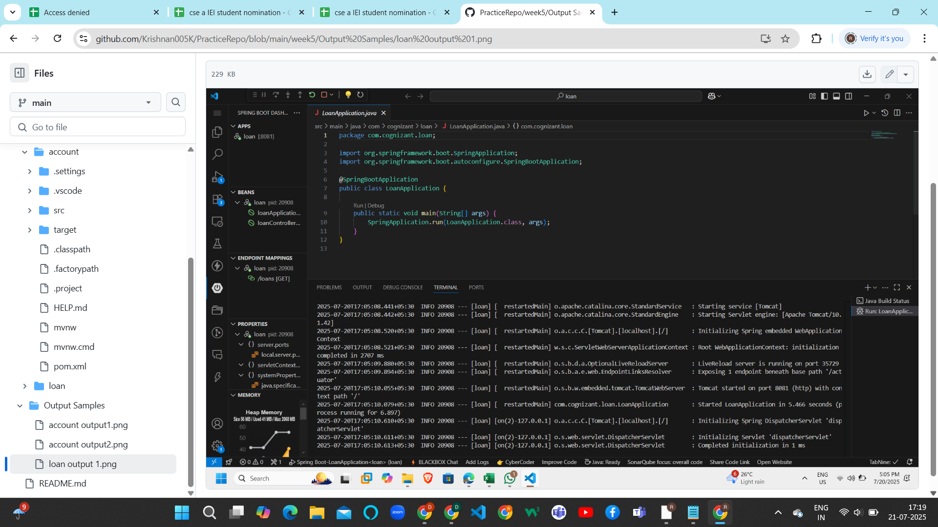

For AccountService:

{

"accountId": "101",

"accountType": "Savings",

"balance": 10000.5

}

For LoanService:

{

"loanId": "L101",

"loanType": "Home Loan",

"loanAmount": 250000.75

}